**Jericho Bruce Rivero | BSIT**

**FUNDAMENTALS OF DATABASE SYSTEMS**

**FINAL SUBMISSION: THE WELLMEADOWS HOSPITAL**

1. **INPATIENT**

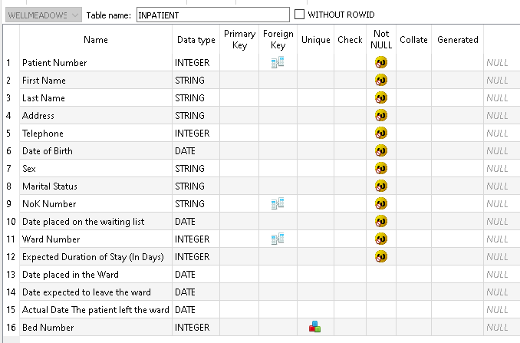

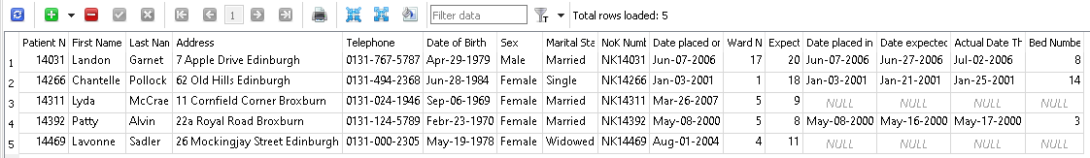

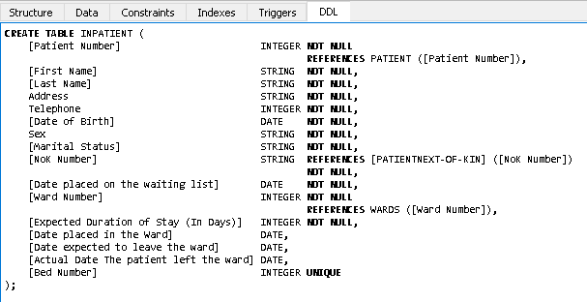

1. **LOCALDOCTORS**

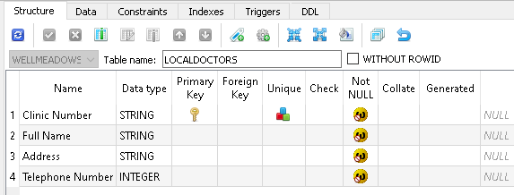

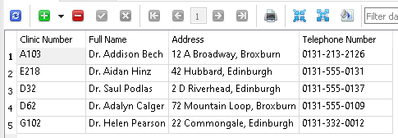

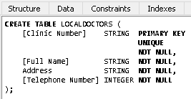

1. **OUTPATIENT**

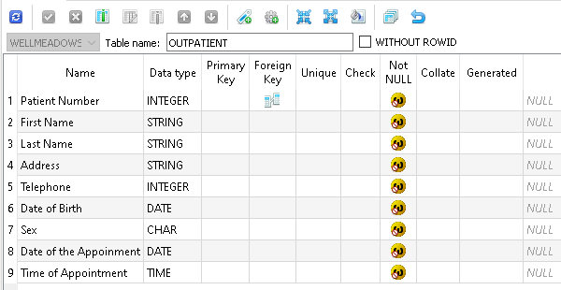

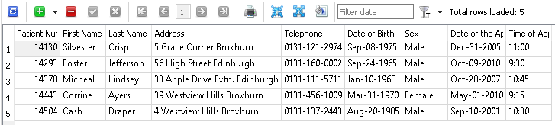

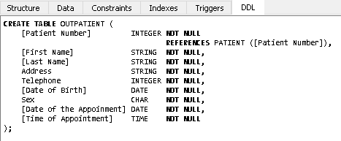

1. **PATIENT**

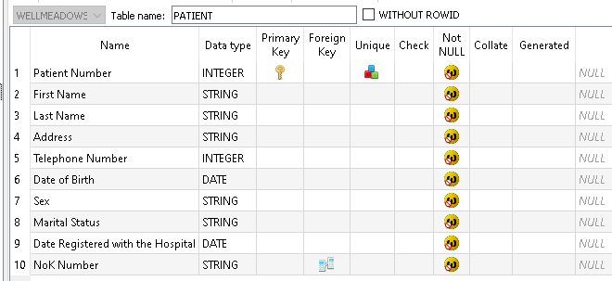

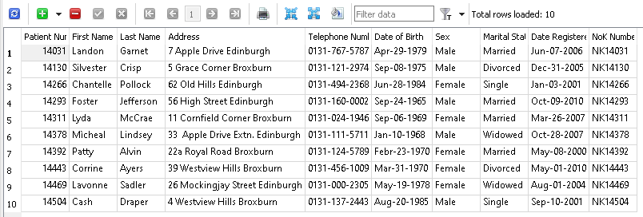

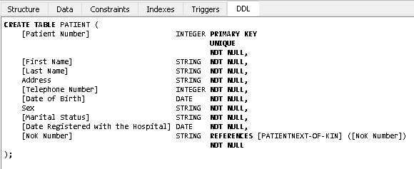

1. **PATIENTAPPOINTMENTS**

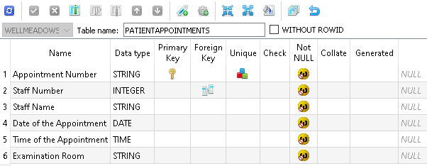

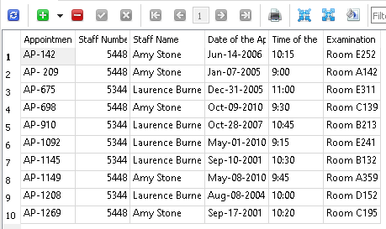

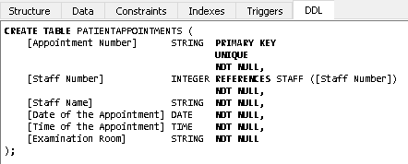

1. **PATIENTMEDICATION**

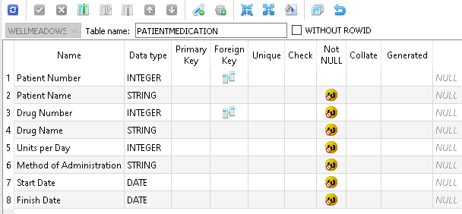

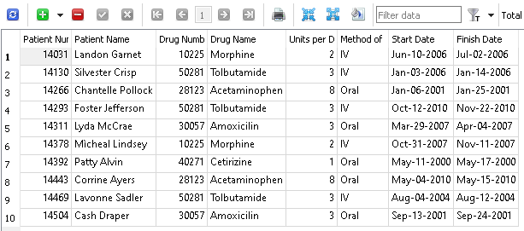

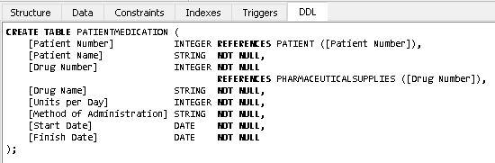

1. **PATIENTNEXT-OF-KIN**

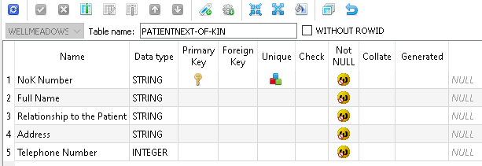

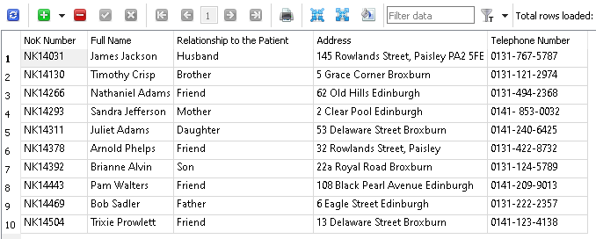

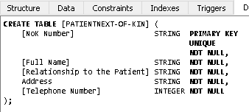

1. **PHARMACEUTICALSUPPLIES**

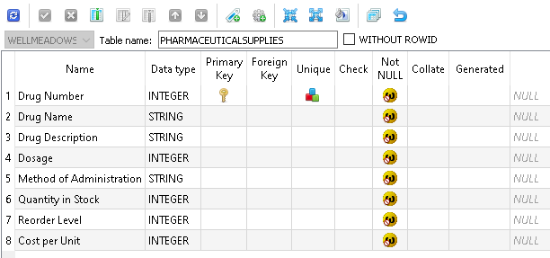

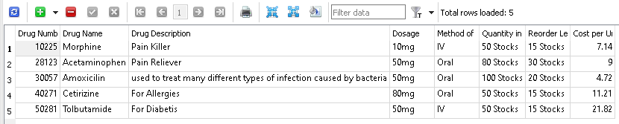

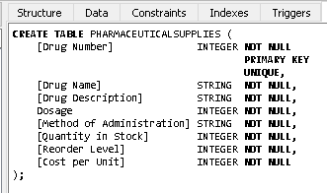

1. **STAFF**

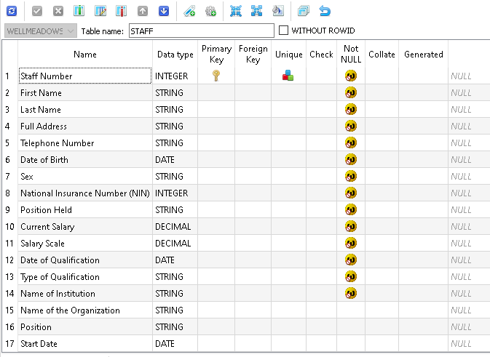

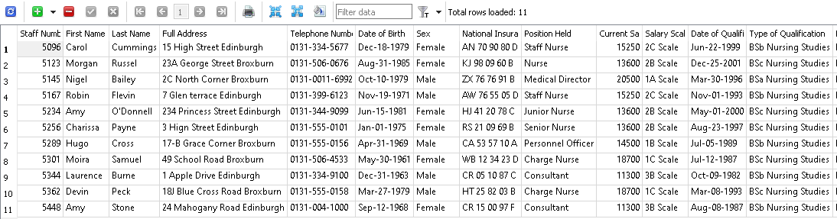

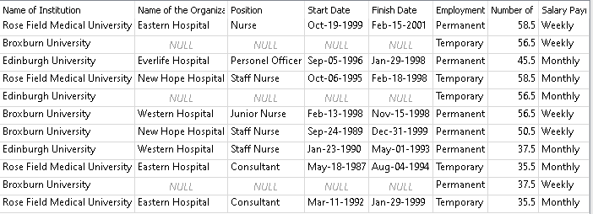

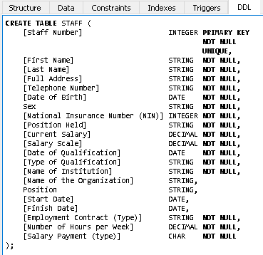

1. **SUPPLIERS**

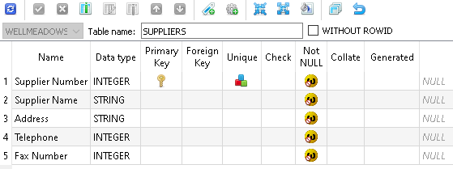

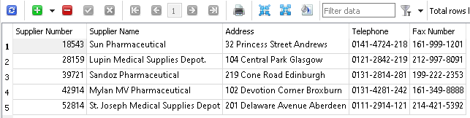

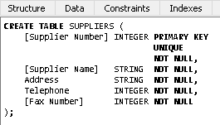

1. **SURGICALANDNON-SURGICALSUPPLIES**

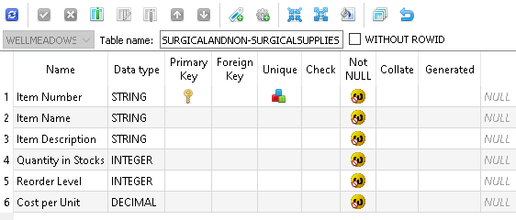

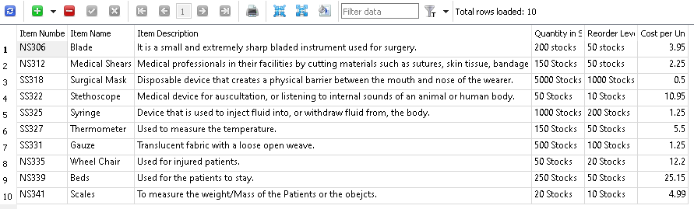

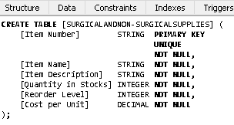

1. **WARDREQUISITION**

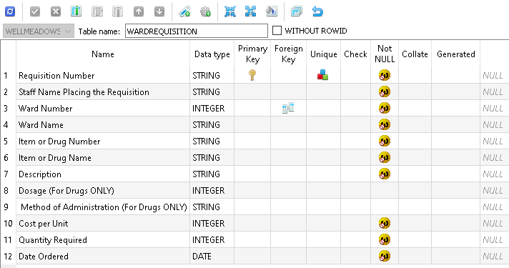

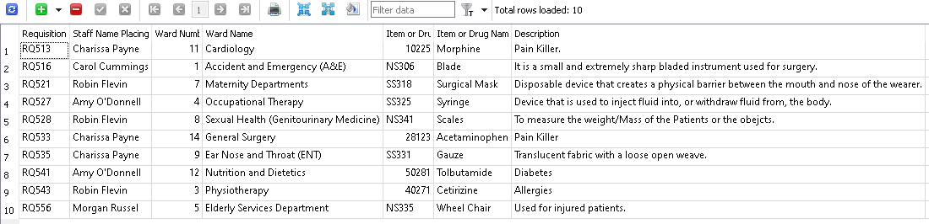

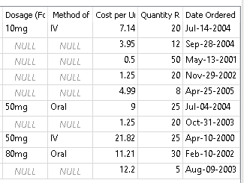

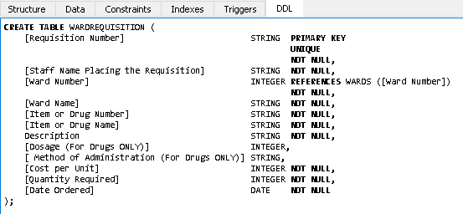

1. **WARDS**

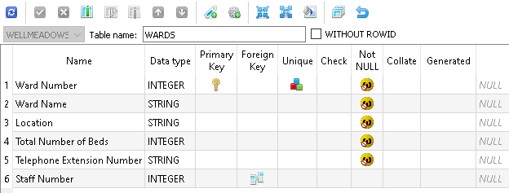

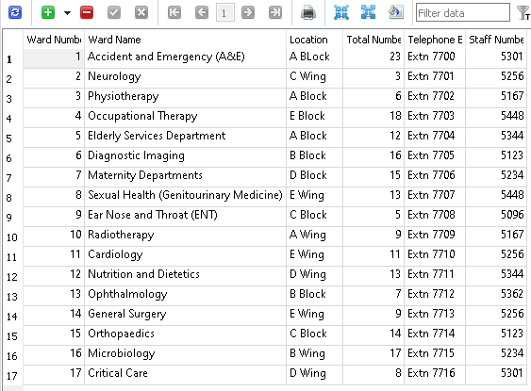

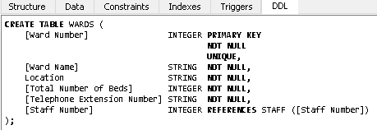

1. **Member of Staff**



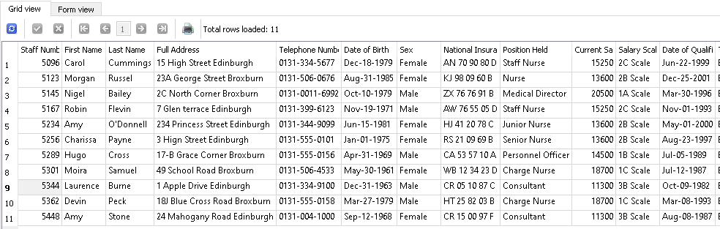

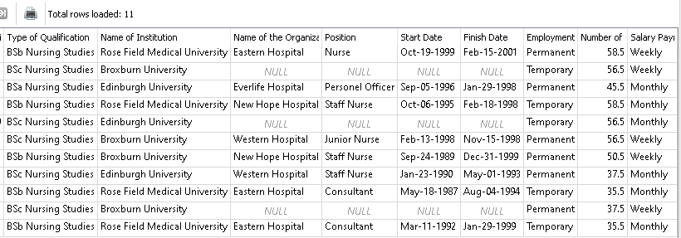

1. **Work Exp**



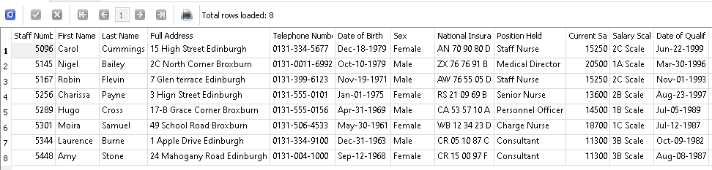

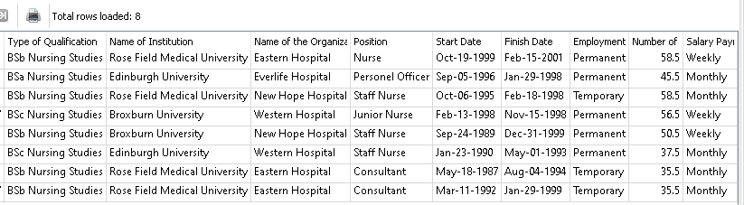

1. **Staff Each Ward**



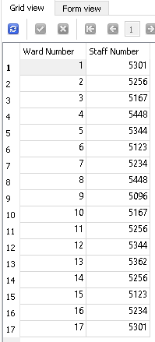

1. **Patient referred to the Hospital**



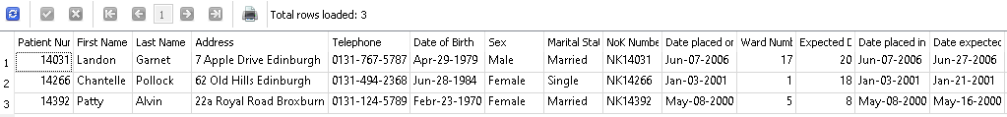

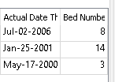

1. **Outpatient**



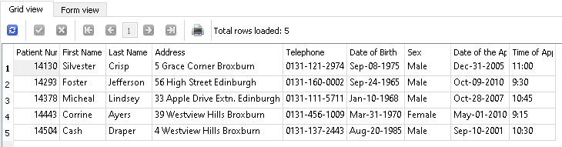

1. **Referred to the Out-Patient**





1. **Patient(s) Referred to Ward 17**





1. **Elderly Services Department**





1. **Patients on the Waiting List on Ward 4**





1. **Medications given to Corrine Ayers**



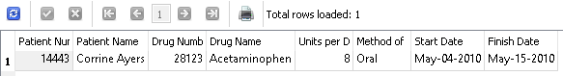

1. **Medications given to Corrine Ayers**



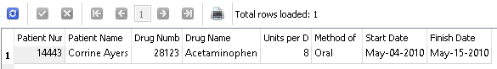

1. **Suppliers of Well Meadows Hospital**



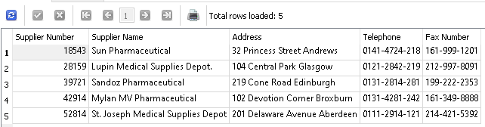

1. **Supply requisitions for wards 1- 10**



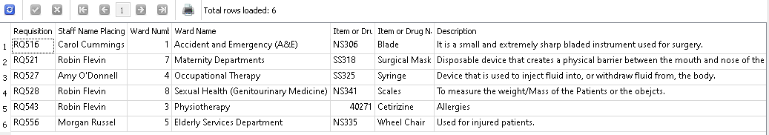

1. **Supply requisitions for wards 10 – 17**



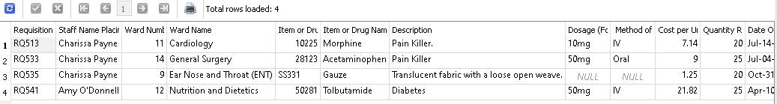

Member Dinner (MEMBER NUM, MEMBER NAME, MEMBER ADDRESS, DINNER NUM, DINNER DATE,

VENUE CODE, VENUE DESCRIPTION, 1{FOOD CODE, FOOD DESCRIPTION}n)